1. What does the <td> element correspond to on the game board?
   1. The <td> tag represents the cell’s location in the grid, so we have 7*7 grid which is 49 squares.
   2. Top left square will be “00” so I should make the first <td> element has an id of “00” and the list goes on by order for the 49 square grid for the game (“01, “02”,…..).
2. What is the collision function responsible for?
   1. The collision function/ method takes a ship and checks to see if any of the locations overlap or collide – with any of the existing ships already on the board:

1. How can you cheat and get the locations of the ships during runtime in the final game?
   1. To cheat, open up the developer console, and type model.ships.
   2. Then press return and you should see the three ship objects containing the locations and hits arrays.
   3. Now you have the inside scoop on where the ships are sitting in the game board.
2. We represent each ship in the game with a/an _________________.
   1. We represent each ship in the game with an **object** that holds the locations it sits in.
   2. An example of the object is stated in question 9.
3. To add a “hit” to the game, what do we add to the corresponding <td> element?
   1. Based on the game model, the attributes for element <td> are added dynamically when we have a hit.

function displayHit(location) {

var cell = document.getElementById(location);

cell.setAttribute(**“class”, “hit”)**

}

* 1. So the answer should correspond to the <td> tag, we have to add a class “hit” to add a hit to the game.

1. What are the 3 objects that are used in Battleship 2.0?
   1. Model :
      1. Which will hold the state of the game, like where each ship is located and where it’s been hit.
   2. View:
      1. Which is responsible for updating the display with hits, misses and messages for the user.
   3. Controller:
      1. Which glues everything together by handling the user input, making sure the game logic gets played and determining when the game is over.
2. What method is used to set the class of an element?
   1. setAttribute method
3. Each object in the game has ____________ primary responsibility.
   1. Each object in the game has **its own** primary responsibility.
   2. The details of each object in the Battleship game is stated in question 6
4. How would you implement chaining in JavaScript? Explain what chaining is and what it does. Show me an example in code from Battleship 2.0.
   1. Chaining isn’t necessary nor much more efficient, but it does make the code shorter and not redundant which make it easier to read than multiple lines of code.
   2. It is preferable to use chaining wisely though, so we shouldn’t code really long chains, they will be harder to read and understand that way.
   3. With chaining, you can string together object references (using the dot operator), thus combining statements and eliminating temporary variables.
   4. Example from the code, is simply defining all 3 ships in one array of objects variable instead of defining three different variables (var ship1={}; var ship2={}; ……)

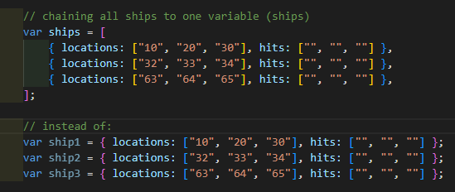

1. How are do-while loops and while loops similar? How are they different?
   1. The do while loop is similar to the while loop **except that the condition is checked after the statements in the body of the loop have executed once**.
   2. Example from the code for the generateShipLocations function:

